**SpringBoot-Aggregate DP Sample**

**Prerequisites**

We must have installed the following

* JDK 1.7 or later
* Maven 3 or later

**Project Structure**

├── src

│   └── main

│   ├── java

│   │   └── com

│   │   └── aggregate

│   │   └── microservice

│   │   ├──pojorest

│   │   │ └──MicroserviceController.java

│  │  ApplicationConfig.java.java

│ │ SpringBootMicroServiceDataApplication.java

│   └── resources

│     ├── application.properties

│

│

└── pom.xml

**Project dependencies**

|  |
| --- |
| **Pom.xml** |
| <project xmlns="http://maven.apache.org/POM/4.0.0" xmlns:xsi="http://www.w3.org/2001/XMLSchema-instance" xsi:schemaLocation="http://maven.apache.org/POM/4.0.0 http://maven.apache.org/xsd/maven-4.0.0.xsd">  <modelVersion>4.0.0</modelVersion>  <groupId>com.aggregate.sbmdbd</groupId>  <artifactId>microservicesample</artifactId>  <version>0.0.1-SNAPSHOT</version>  <name>SpringBootJPASpringData</name>  <description>SpringBootJPASpringData project for Spring Boot with Spring Data JPA implementation</description>  <parent>  <groupId>org.springframework.boot</groupId>  <artifactId>spring-boot-starter-parent</artifactId>  <version>1.4.0.RELEASE</version>  <relativePath/> <!-- lookup parent from repository -->  </parent>  <properties>  <project.build.sourceEncoding>UTF-8</project.build.sourceEncoding>  <project.reporting.outputEncoding>UTF-8</project.reporting.outputEncoding>  <java.version>1.8</java.version>  </properties>  <dependencies>  <dependency>  <groupId>org.springframework.boot</groupId>  <artifactId>spring-boot-starter-web</artifactId>  </dependency>  <dependency>  <groupId>org.springframework.boot</groupId>  <artifactId>spring-boot-starter-test</artifactId>  <scope>test</scope>  </dependency>  </dependencies>  <build>  <plugins>  <plugin>  <groupId>org.springframework.boot</groupId>  <artifactId>spring-boot-maven-plugin</artifactId>  </plugin>  </plugins>  </build>    </project> |

**Application Configuration**

|  |
| --- |
| **SpringBootMicroServiceDataApplication.java** |
| **Path 🡪src/main/java/com/aggregate/microservice/SpringBootMicroServiceDataApplication.java** |
| package com.aggregate.microservice;  import org.springframework.boot.SpringApplication;  import org.springframework.boot.autoconfigure.SpringBootApplication;  @SpringBootApplication  public class SpringBootMicroServiceDataApplication {  public static void main(String[] args) {  SpringApplication.run(SpringBootMicroServiceDataApplication.class, args);  }  } |

|  |
| --- |
| **ApplicationConfig.java** |
| **Path 🡪 src/main/java/com/aggregate/microservice/ApplicationConfig.java** |
| package com.aggregate.microservice;  import org.springframework.context.annotation.Bean;  import org.springframework.context.annotation.Configuration;  import org.springframework.web.client.RestTemplate;  @Configuration  public class ApplicationConfig {      @Bean  public RestTemplate restTemplate() {  RestTemplate restTemplate = new RestTemplate();  return restTemplate;  }  } |

**Controller File**

|  |
| --- |
| **MicroserviceController.java** |
| **Path 🡪 src/main/java/com/aggregate/microservice /pojorest /MicroserviceController.java** |
| package com.aggregate.microservice.pojorest;  import java.util.ArrayList;  import java.util.Arrays;  import java.util.HashMap;  import java.util.List;  import java.util.Map;  import javax.validation.Valid;  import org.springframework.beans.factory.annotation.Autowired;  import org.springframework.web.bind.annotation.RequestBody;  import org.springframework.web.bind.annotation.RequestMapping;  import org.springframework.web.bind.annotation.RestController;  import org.springframework.web.client.RestTemplate;  @RestController  @RequestMapping("/microservice")  public class MicroserviceController {    @Autowired  private RestTemplate restTemplate;    @RequestMapping("/ReadAll")  public Iterable<Object> readAllMongoDB() {    List<Object> mongodb=new ArrayList<Object>();  List<Object> mySQL=new ArrayList<Object>();  List<Object> merge=new ArrayList<Object>();  try{  mongodb = Arrays.asList(restTemplate.getForObject("http://localhost:8083/booking/read-all", Object[].class));  mySQL = Arrays.asList(restTemplate.getForObject("http://localhost:8082/booking/readAll", Object[].class));  merge = new ArrayList<Object>(mongodb);  merge.addAll(mySQL);  }catch(Exception e){  System.out.println("Connection Exception"+e.getMessage());  }  return merge;    }    } |

**Application.properties**

|  |
| --- |
| **application.properties** |
| **Path 🡪 src/main/resources/application.properties** |
| server.port = 8084 |

**Steps to Test the Application**

D:\Karthik-ws\code\SpringBoot-SpringDataJPA-Mysql >mvn spring-boot:run

Once the server has been started. Enter the below url in the SOAPUI and select POST method.

**View All**

<http://localhost:8084/microservice/ReadAll>

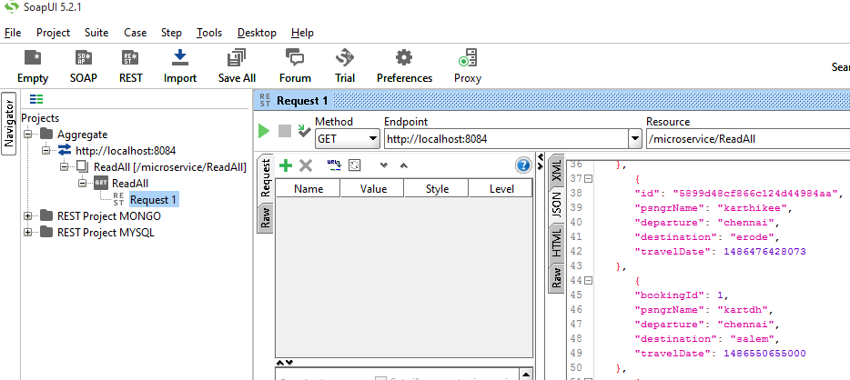

**Browser**

<http://localhost:8084/microservice/ReadAll>

